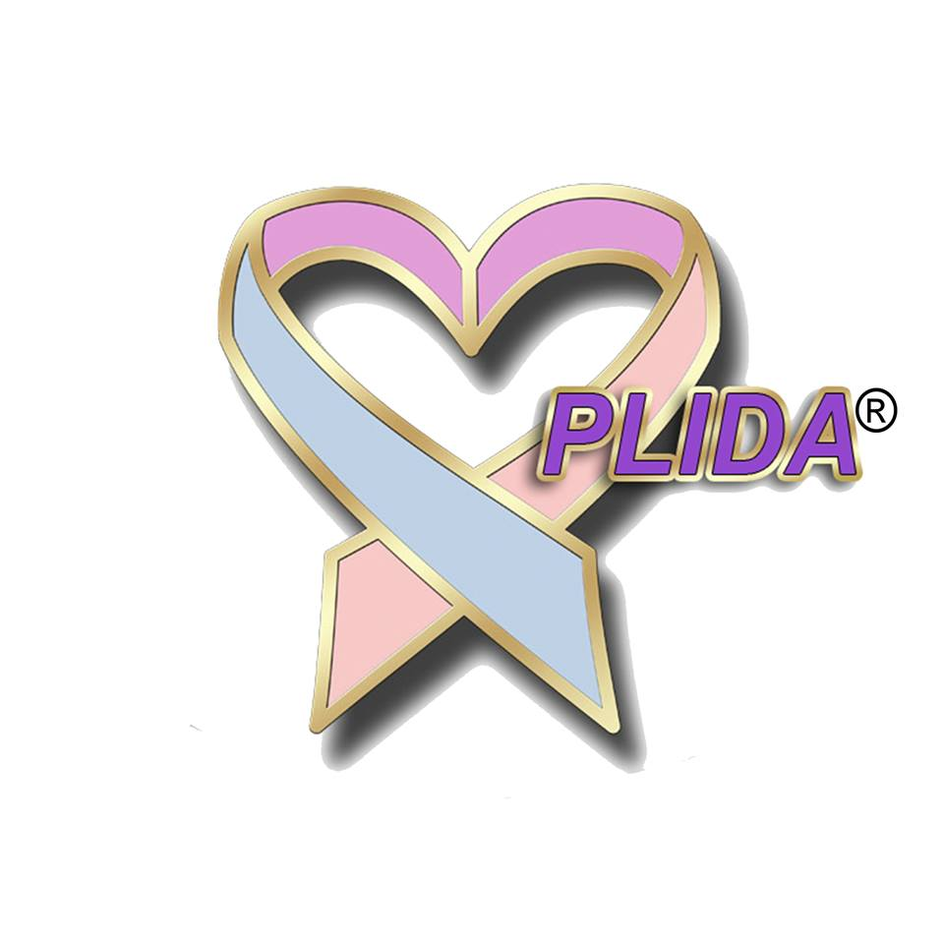
Webinar Series Call for Proposals

- Introduction

The Pregnancy Loss and Infant Death Alliance’s Education and Diversity, Equity, & Inclusion Committees are seeking presenters for the 2023-2024 Perinatal Bereavement Webinar Series. Presenters are invited to share evidence-based clinical practice, research, and experiential opportunities that reflect the theme of increasing inclusivity in perinatal bereavement care to families within an interprofessional team. We invite submissions from those seeking the chance to share their work with an interprofessional audience using a webinar-based format.

- Webinar Series objectives
  - Explore ways of increasing inclusivity in perinatal bereavement care to families.
  - Explore ways of increasing inclusivity/diversity among health care provider teams.
  - Identify skills for working within an interprofessional team when providing care for bereaved families.
  - Examine ways of promoting health equity through health care access and quality in the perinatal population.
  - Discuss trauma related to death, unexpected outcomes, and insensitive care during childbearing.
  - Explore communication skills appropriate for the perinatal period.
  - Describe grief and bereavement in diverse populations.
  - Provide opportunities for relationship building.
  - Explain principles and practice of self-care.
  - List ways of translating research findings into clinical practice to promote a compassionate standard of care for bereaved families.
  - Provide opportunities for relationship building among parent advocates, educators, clinical care providers, and researchers.
- Review Criteria

Proposals will be reviewed by members of the Education and DEI Committees using these criteria:
- Topic is innovative and relevant to perinatal bereavement care.
  - Submission focuses on one or more of these areas: clinical practice, research, education, and/or advocacy.
  - Time allocation and presentation content are well organized.
  - Presenter has appropriate and relevant presentation experience.
  - Learning objectives are measurable (i.e., using verbs such as discuss, describe, list, explain; avoid the verb “understand”).
  - Participants are likely to have significant interest in the session.
  - Presentations should include experience of/perspectives from diverse populations regardless of topic (example: if the topic is “keepsake collection” DEI perspectives on how keepsakes are offered, and culturally sensitive approaches are highlighted.)

- SPEAKER SUBMISSION REQUIREMENTS

  - The series will consist of 6 webinars scheduled September 2023 through March 2024. They will take place on September 21, October 19. November 16, January 18, February 15, and March 21 from 3-4 pm CST. We are unable to accommodate specific requests for presentation scheduling, so speaker must be available for at least two dates. The webinar is presented live and will include time for questions.
  - Speaker must also be available for a webinar rehearsal session with Event (webinar) Planners, one week prior to their scheduled presentation.
  - Submission is limited to a maximum of 2 speakers per proposal. All speakers are required to be present during the webinar.
  - Speakers must have access to
    - a computer with camera and microphone
    - Internet service
    - Zoom platform
    - pleasant lighting (e.g., daylight, an “O” ring light), and a designated quiet space to conduct the webinar
  - Speaker will email handouts (pdf) to organizers two days prior to the rehearsal session.
  - Speaker will receive an honorarium of $500. Two speakers will divide that amount.
  - Sessions will be recorded and available to view through the PLIDA website for member purchase (subject to presentation content).

- TOPICS OF INTEREST

Webinar planners are looking for proposals on the following topics:

- Healthy Equity
- Culturally diverse practices: how to incorporate and/or support programs that highlight, encourage, teach, and provide culturally diverse care.
- Bereavement support at different times of childbearing (prenatal, labor & delivery, postpartum, subsequent pregnancy)
- Disparities in perinatal care/bereavement support in underserved maternal populations (LGBTQ+, BIPOC-identifying, gestational carriers)
- Evaluation of systemic racism as a barrier to implementation of perinatal palliative care practices
- Maternal death
- Anti-racism advocacy in perinatal palliative care
- Perinatal and neonatal palliative care
- Self-care, caregiver grief or suffering in perinatal care, moral distress
- Traumatic or complicated bereavement
- Types of loss (miscarriage, stillbirth, neonatal, infant death)

- Webinar SESSION SUBMISSION

  - Please complete the following forms and submit as your proposal:
    - Educational Planning Table
    - GAP Analysis Form
    - Biographical and Conflict of Interest Form (one per speaker*)
  - The Educational Planning Table, GAP Analysis Form, and Biographical and Conflict of Interest Form are required to award continuing education credits. PLIDA Educational Specialist will be applying for continuing education credits for nurses, social workers, psychologists/therapists, and physicians.
  - Webinar presentations must include 15 minutes for audience questions as part of this 60-minute session.
  - All forms must be typed; handwritten documents will not be accepted.
  - Submission is limited to a maximum of 2 speakers per proposal.
  - Webinar planners will not review incomplete, incorrect, or late submissions.
  - Please submit completed forms via email to rose.carlson@plida.org by May 1, 2023

*Note: PLIDA recognizes highest completed degrees only. Please do not use degree candidacy in your credentials [e.g., DNP(c)]. This is standard practice in most universities and colleges as a way of recognizing the work that goes into degree completion.

- Notification of Decision:

Those who submit a proposal will receive email notification of the reviewers’ decision no later than June 1, 2023. Those selected to present a webinar will receive an agreement and presenter information packet with the notification.

Educational Planning Table Instructions
Webinar Proposals

TITLE OF PRESENTATION/SESSION: Title must reflect the topic or content (20 words or less). For example, the title should include key words that relate to the content.

SECTION 1: INFORMATION FROM PLANNERS TO PRESENTERS/AUTHORS: Must be completed by speaker.

SECTION 2: PRESENTATION INFORMATION:
All webinar sessions will be 60 minutes. Presenters should provide at least 10 minutes for discussion and questions.

- MAIN POINTS/TOPICS: include at least two and no more than three behavioral learning objectives. Behavioral objectives are measurable. Written from the perspective of the learner (e.g., “As a result of attending this presentation, the participant will be able to describe, discuss, define, or list…”). Avoid verbs such as “understand” and “know.”
- CONTENT OUTLINE: It must be more than a restatement of the objectives. Please thoroughly provide the content of your talk. Include specific details, not simply an overview. Reviewers will focus on this segment of your proposal to determine if your presentation will meet the expectations for a quality talk.
  - Research submissions should use these sub-headings as part of the CONTENT OUTLINE:
- Objectives |  | - Conclusions
- Background |  | - Clinical implications
- Design and methods |  | - Suggestions for future research
- Results
  - Clinical Practice, Education, or Advocacy Submissions must include these sub-headings in the CONTENT OUTLINE:
- Background
- Description of the practice, innovation, or program (e.g., unique elements)
- Evaluation data (if available)

- TIME FRAME: include time frame for each objective. Webinar session must not exceed 60 minutes and should provide at least 10 minutes for discussion and questions.
- PRESENTER OR AUTHOR: include the full name of the presenter for each objective.
- LEARNER ENGAGEMENT STRATEGIES: Please describe if presentation is a lecture, lecture with Power Point, discussion, handouts, experiential, demonstrations, case studies, or other. MUST include presentation level: basic, intermediate, advanced.
- NOTE WHEN WRITING OBJECTIVES: Please use measurable verbs when writing objectives. Understand and know are not measurable verbs. Use verbs such as discuss, define, list, examine, evaluate, differentiate, evaluate, etc. If you have any questions, reach out to Rose at rose.carlson@plida.org

SECTION 3: EVIDENCE-BASED REFERENCES:

- Bibliography must include at least five (5) references (or 50% of the references, whichever is less) dated within the last four years (2019)
- References must include
  - Author
  - Title
  - Place of Publication
  - Publisher
  - Date of Publication or date information was retrieved/accessed from website
  - APA style: http://www.apastyle.org

SECTION 4: CONTACT HOUR CALCULATION FOR THIS PRESENTATION/SESSION
- Webinar Session: 60 minutes

Gap Analysis Worksheet Instructions
Webinar Proposals

EDUCATIONAL ACTIVITY: Include same title of presentation/session as the one used on the Educational Planning Table
Please see following example:

GAP ANALYSIS SAMPLE WORKSHEET
Instructions: Type directly into blank cells of the tables. Save the completed form to your computer.
Educational Activity: | Resolve Through Sharing Coordinator Training

Desired State | Current State | Identified Gap | Gap due to Knowledge, Skills or Practice | Purpose | Outcome Measure
Participants will have the tools to create and sustain a bereavement program in their own institutions. | Bereavement program in non-existent or needing revitalization. | Staff and management at institutions identify the need for a bereavement champion or a leader for the development and sustainment of a bereavement program. | Staff lacks the leadership skills and the tools to understand and navigate change in their unit/ department. There is a gap in the skills to coordinate a bereavement program. There is also a gap in the knowledge and skills to do educational presentations/ programs. | To provide participants with the knowledge and skills needed to create and sustain a bereavement program as well as provide bereavement education. | Participants will attend and interact with others intending to create and sustain a bereavement program.  Participants will do a coordinator pre and post assessment. During the course they will also be indicating a date that they want to offer their first educational activity at their institution. Participants receive an email supporting their plan to present 4 months prior to their chosen presentation date and a phone call 8 weeks prior.

Add more rows as needed by placing cursor outside of last row and clicking ‘Enter’ key.
TIPS FOR WRITING A CURRICULUM VITAE (CV) OR BIOSKETCH

- NOTE: if you already have a CV or biosketch, you do not need to create another one; feel free to use the one you have, just make sure your contact and professional information is current/up-to-date.
- PERSONAL INFORMATION: include your name, credentials, current employer, position, and contact information (address, phone number and email address) at the top.
- EDUCATION: include the college/university, highest degree obtained, and year completed.
- EMPLOYMENT HISTORY: List each position you have held and a brief description of your responsibilities.
- ACHIEVEMENTS: In this section, list publications, board positions, awards, etc.

If you have extensive experiences, you do not need to give in-depth detail about each of them. You can simply highlight those things which are most relevant to the perinatal bereavement field and the topic you are speaking on. If you have any questions, please reach out to Rose at rose.carlson@plida.org

IMPORTANT DATES TO REMEMBER:

- MAY 1, 2023: webinar presentation proposals due
- JUNE 1, 2023: acceptance/declination email will be sent.
- JUNE 23, 2023: agreements and marketing forms go out to selected speakers and poster presenters.
- JUNE 30, 2023: deadline for signed Speaker Agreements, deadline for Session Description and Speaker Bios and Picture
- APRIL 15, 2024: deadline to submit speaker handouts.

THANK YOU for your time, and all of us at PLIDA look forward to reading about the work you do to support bereaved families in your community!

