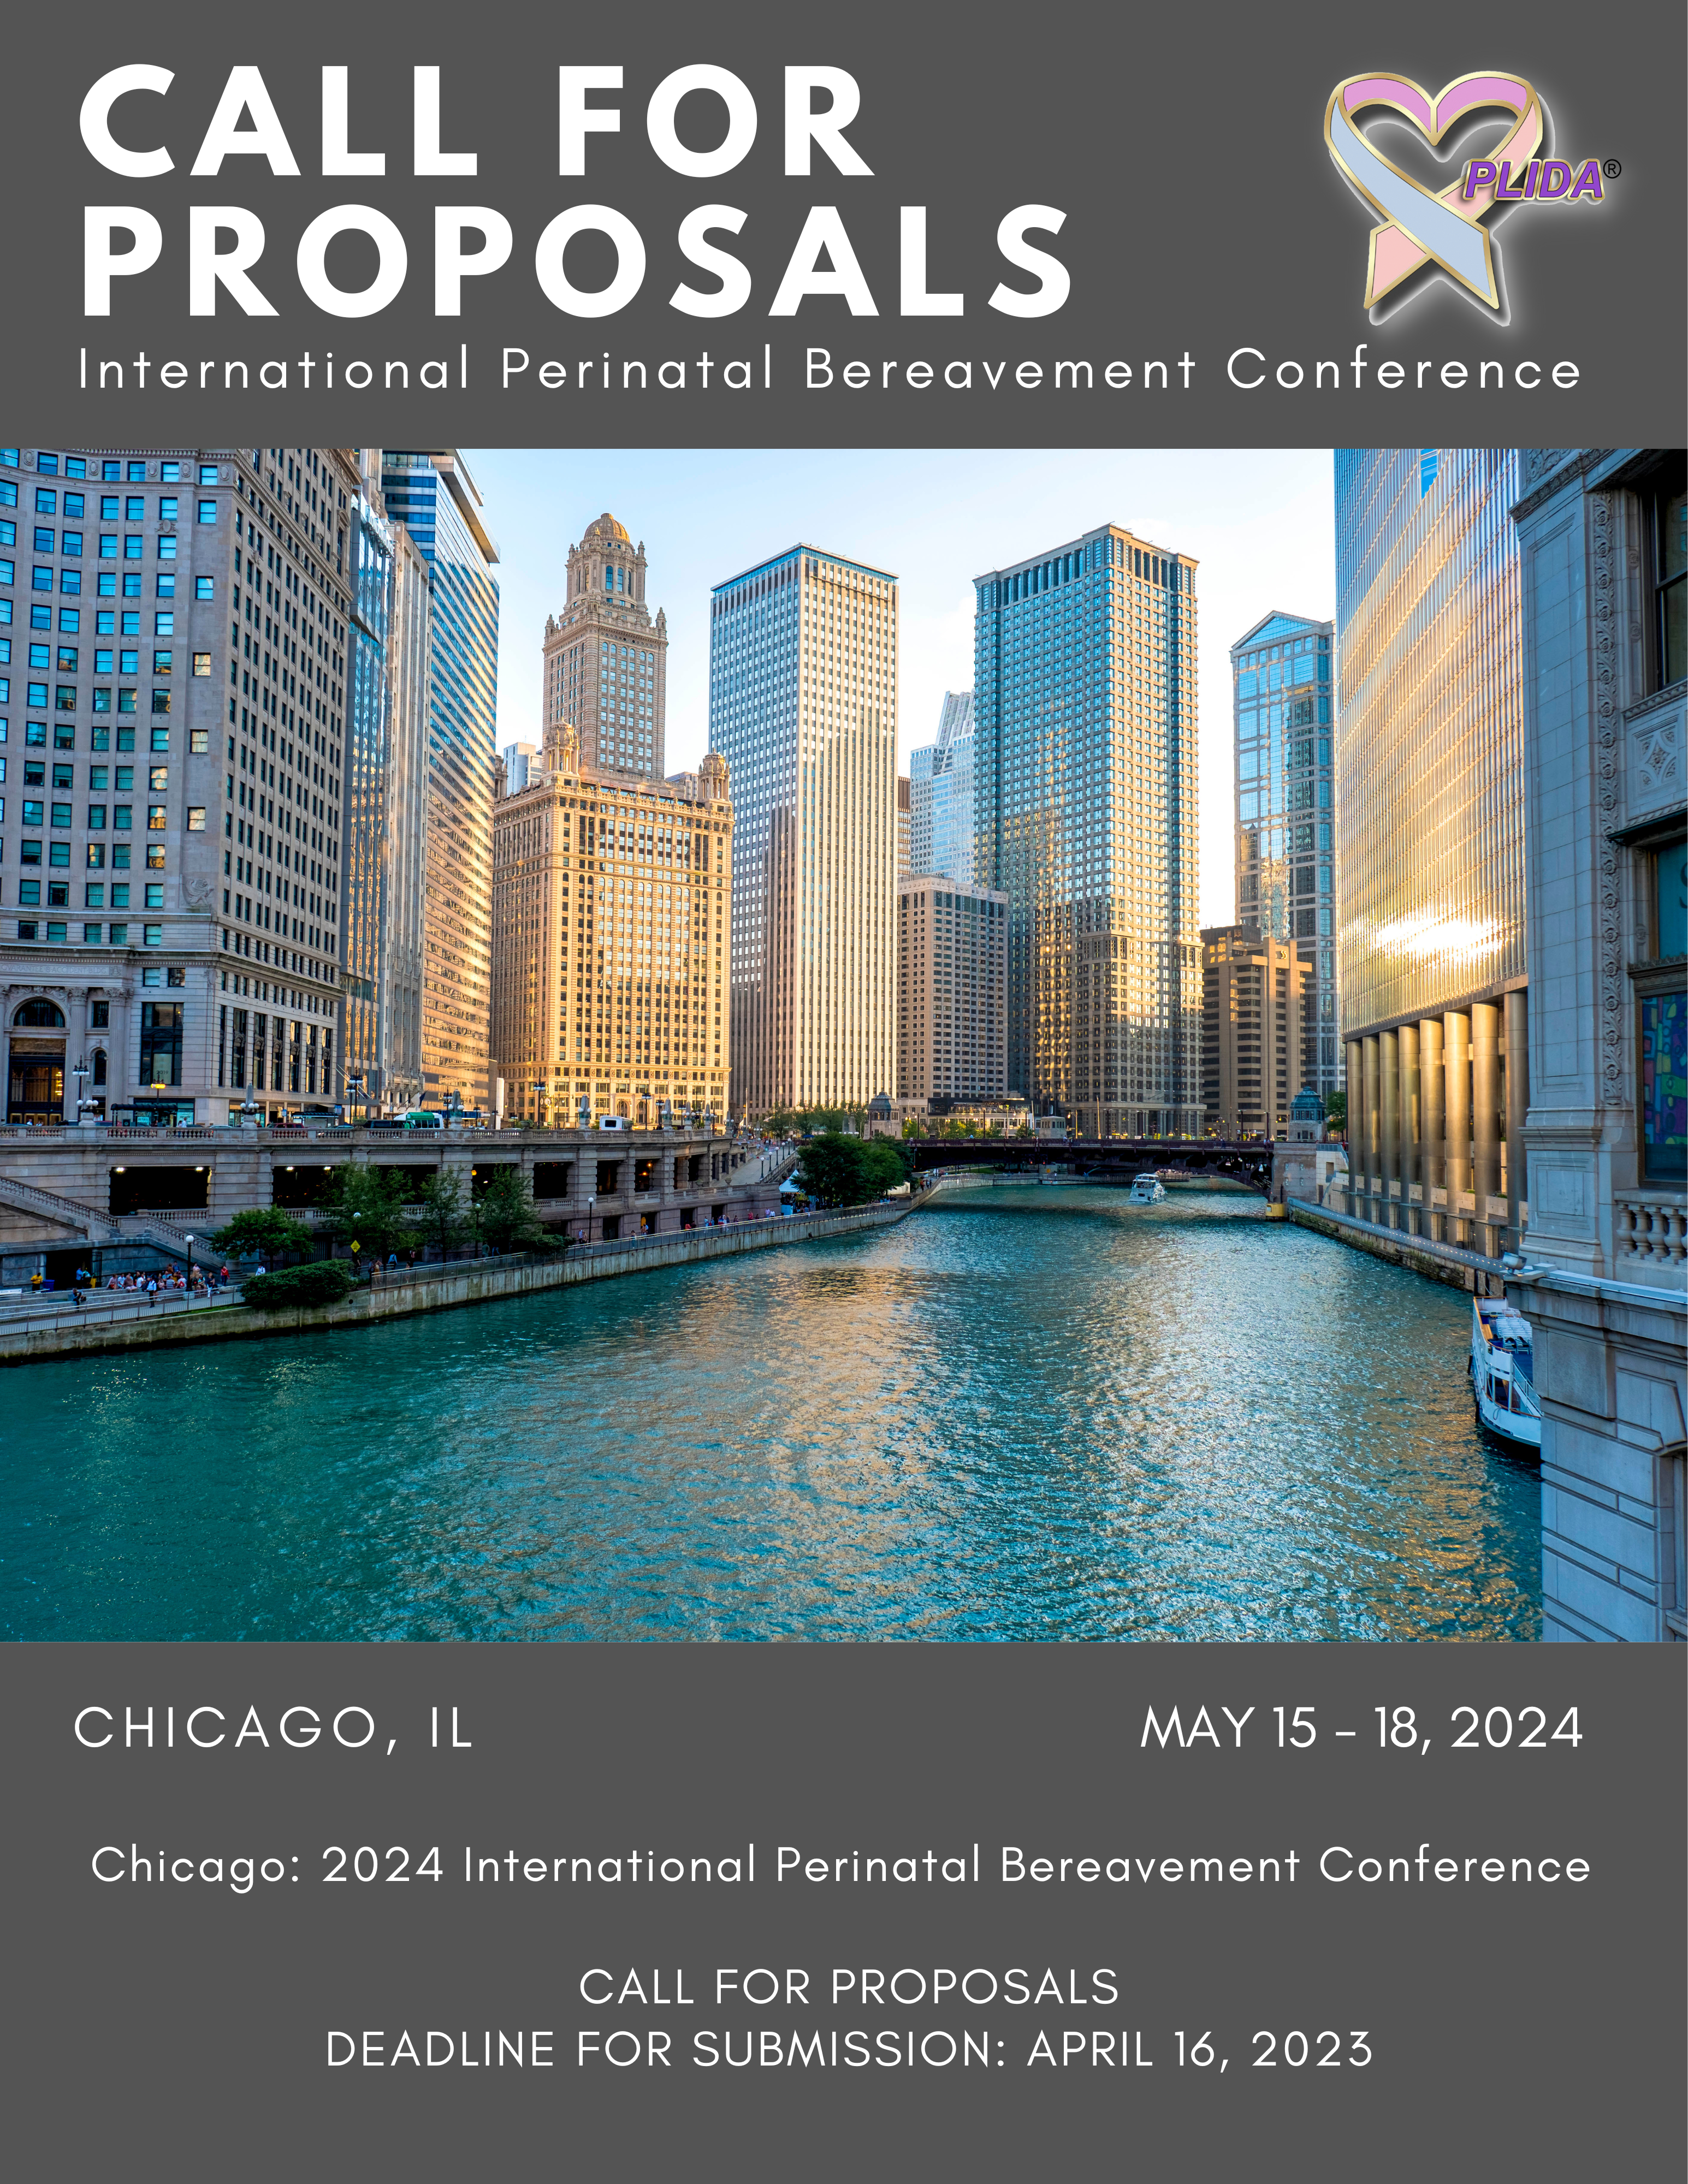
Call for Proposals
Chicago: 2024 International Perinatal Bereavement Conference

- Introduction
The International Perinatal Bereavement Conference (IPBC) is a major educational and networking event expected to draw more than 400 professionals and parent advocates interested in perinatal bereavement care. This 3.5-day conference includes one day of pre-conference presentations followed by 2.5 days of plenary, concurrent, and networking sessions.

The 2024 PLIDA Education and Planning Committees seek concurrent and poster presenters for the 22nd Biennial International Perinatal Bereavement Conference May 15-18, 2024, at the Drake Hotel, Chicago, IL. Presenters are invited to share evidence-based clinical practice, research, and experiential opportunities with an interprofessional audience. Attendees will include clinicians, researchers, educators, and parent advocates (e.g., nurses, social workers, chaplains, physicians, genetic counselors, mental health providers, child life specialists, care coordinators) whose work involves women and families experiencing miscarriage, stillbirth, newborn and infant death, and babies diagnosed during the mother’s pregnancy with a life-threatening condition.

The Conference Planning Committee is seeking submissions for concurrent session presentations and posters that reflect the conference theme JOIN US IN CHICAGO: UNITING RELATIONAL ASPECTS OF PERINATAL BEREAVEMENT CARE AND CLINICAL RESEARCH.

- Conference Objectives
- Identify skills for working within an interprofessional team when providing care for bereaved families.
- Examine ways of promoting health equity through health care access and quality in the perinatal population.
- Discuss trauma related to death, unexpected outcomes, and insensitive care during childbearing.
- Explore communication skills appropriate for the perinatal period.
- Describe grief and bereavement in diverse populations.
- Provide opportunities for relationship building.
- List ways of translating research findings into clinical practice to promote a compassionate standard of care for bereaved families.
- Explain principles and practice of self-care.
- Review Criteria
Proposals will be reviewed by members of the Education and Conference Planning Committees using these criteria:
- Topic is innovative and relevant to perinatal bereavement care.
  - Submission focuses on one or more of these areas: clinical practice, research, education, and/or advocacy.
  - Time allocation and presentation content are well organized.
  - Presenter has appropriate and relevant presentation experience.
  - Learning objectives are measurable (i.e., using verbs such as discuss, describe, list, explain and avoid the verb “understand”)
  - Participants are likely to have significant interest in the session.

- SPEAKER REQUIREMENTS
  - Speaker and Poster Presenters are required to register for the main conference. Preconference registration is optional.
  - Poster Presenters are expected to be at their posters and available for questions during specified times.
  - Presentations will be scheduled for either May 16 or May 17. We are unable to accommodate specific requests for presentation scheduling, so speaker must be available on either date.
  - In gratitude there is one $100.00 registration discount per proposal that is accepted as a concurrent or poster presentation
  - Submissions with more than one speaker will receive only one discount to be shared among presenters.
  - Submission is limited to a maximum of 2 speakers per proposal. All speakers are required to register for the main conference.
  - Speakers and Poster Presenters are responsible for all travel and lodging expenses, including parking.

TOPICS OF INTEREST
Conference planners encourage proposals on the following topics:
Supporting Families Through Loss of  the Expected Pregnancy |  | Ethical Issues and Decision Making
Disparities in Perinatal Bereavement Care |  | Miscarriage Care Across the Health Care System
Perinatal Bereavement Mental Health |  | Traumatic or Complicated Bereavement
Current Theories, Models, and Concepts |  | Perinatal Loss and Expressive Therapies
Integration of Evidence-Based Practices |  | Managerial, Leadership, Administrative  Roles in Bereavement Programs
Traumatic Grief |  | Parental Advocacy
Cultural Response to Pregnancy Loss and Death |  | Ritual, Suffering, and Hope
Prenatal Care Planning |  | Mentoring Relationships in Perinatal  Bereavement
Supporting Families Through  Decision Making |  | Maternal Mental Health
Perinatal Bereavement Care for Families  Choosing Medical Termination |  | Stillbirth
Genetics and Genomics In Perinatal Care |  | Maternal Death
Perinatal Palliative Care |  | Self-Care: Caregiver Grief and Suffering in Perinatal Loss
Role of Fetal Center Care Coordination |  | Perinatal Loss: The Grief of Children
Memory Making During Pregnancy |  | Perinatal Loss: Grief of Grandparents and Other  Family Members
Perinatal Loss: Caring for Marginalized  Populations |  | Quality and Safety Measures
Collaborative Bereavement Care Models |  | Moral Distress
Developing a Reflective Practice |  | Spiritual Care
Mindfulness and Meditation |  | Growth and Transformation

- CONCURRENT SESSION SUBMISSION
  - Please complete the following forms and submit as your proposal:
    - EDUCATIONAL PLANNING TABLE
    - CURRICULUM VITAE or BIOSKETCH per speaker and planning committee member* (See below for guidelines)
    - CONFLICT OF INTEREST FORM per speaker
    - GAP ANALYSIS FORM
  - The EDUCATIONAL PLANNING, PLANNER/FACULTY CURRICULUM VITAE or BIOSKETCH, CONFLICT OF INTEREST and GAP ANALYSIS FORMS, are required to award continuing education credits. We appreciate your assistance in maintaining records as prescribed by Rush University Medical Center’s Office of Interprofessional Continuing Education and other continuing education providers.
  - Concurrent presentations must include 10 minutes for audience questions as part of this 60-minute session.
  - All forms must be typed; handwritten documents will not be accepted.
  - Submission is limited to a maximum of 2 speakers per proposal.
  - Conference planners will not review incomplete, incorrect, or late submissions. Please review instructions at the end of this document or tutorial available on our website www.plida.org
  - Please submit completed forms via email to rose.carlson@plida.org by April 24, 2023.
*Note: PLIDA recognizes highest completed degrees only. Please do not use degree candidacy in your credentials [e.g., DNP(c)]. This is standard practice in most universities and colleges as a way of recognizing the work that goes into degree completion.

- Poster presentation submission
- Please submit a 1-page proposal for your poster presentation. Please include:
  - Title of the Poster
  - First & Last Name of Author(s)*
  - Detailed Contact Information for each author, including email address.
  - Please include the type of poster you will present (Innovative or Research), in addition to a brief description of each of the headings listed below:
Innovative Program Poster includes |  | Research Poster includes
- objectives |  | - objectives
- background information |  | - introduction
- description |  | - design and methods
- evaluation |  | - results
 |  | - conclusions
- Proposal must be typed; handwritten documents will not be accepted.
- Conference planners will not review incomplete, incorrect, or late submissions.
- Please submit proposals via email to rose.carlson@plida.org by April 24, 2023
*Note: PLIDA recognizes highest completed degrees only. Please do not use degree candidacy in your credentials [e.g., DNP(c)]. This is standard practice in most universities and colleges as a way of recognizing the work that goes into degree completion.

- Notification of Decision

Those who submit a proposal will receive email notification of the reviewers’ decision no later than June 1, 2023. Those selected to present a concurrent or poster session will receive an agreement and presenter information packet by June 23, 2023.

Educational Planning Table Instructions
Concurrent Proposals

TITLE OF PRESENTATION/SESSION: Title must reflect the topic or content (20 words or less). For example, the title should include key words that relate to the content.

SECTION 1: INFORMATION FROM PLANNERS TO PRESENTERS/AUTHORS: Must be completed by speaker.

SECTION 2: PRESENTATION INFORMATION:
All concurrent sessions will be 60 minutes. Presenters should provide at least 10 minutes for discussion and questions.

- MAIN POINTS/TOPICS: include at least two and no more than three behavioral learning objectives. Behavioral objectives are measurable. Written from the perspective of the learner (e.g., “As a result of attending this presentation, the participant will be able to describe, discuss, define, or list…”). Avoid verbs such as “understand” and “know.”
- CONTENT OUTLINE: It must be more than a restatement of the objectives. Please thoroughly provide the content of your talk. Include specific details, not simply an overview. Reviewers will focus on this segment of your proposal to determine if your presentation will meet the expectations for a quality talk.
  - Research submissions should use these sub-headings as part of the CONTENT OUTLINE:
- Objectives |  | - Conclusions
- Background |  | - Clinical implications
- Design and methods |  | - Suggestions for future research
- Results
  - Clinical Practice, Education, or Advocacy Submissions must include these sub-headings in the CONTENT OUTLINE:
- Background
- Description of the practice, innovation, or program (e.g., unique elements)
- Evaluation data (if available)

- TIME FRAME: include time frame for each objective. Concurrent session must not exceed 60 minutes and should provide at least 10 minutes for discussion and questions.
- PRESENTER OR AUTHOR: include the full name of the presenter for each objective.
- LEARNER ENGAGEMENT STRATEGIES: Please describe if presentation is a lecture, lecture with Power Point, discussion, handouts, experiential, demonstrations, case studies, or other. MUST include presentation level: basic, intermediate, advanced.
- NOTE WHEN WRITING OBJECTIVES: Please use measurable verbs when writing objectives. Understand and know are not measurable verbs. Use verbs such as discuss, define, list, examine, evaluate, differentiate, evaluate, etc. If you have any questions, reach out to Rose at rose.carlson@plida.org

SECTION 3: EVIDENCE-BASED REFERENCES:

- Bibliography must include at least five (5) references (or 50% of the references, whichever is less) dated within the last four years (2019)
- References must include
  - Author
  - Title
  - Place of Publication
  - Publisher
  - Date of Publication or date information was retrieved/accessed from website
  - APA style: http://www.apastyle.org

SECTION 4: CONTACT HOUR CALCULATION FOR THIS PRESENTATION/SESSION
- Concurrent Session: 60 minutes

Gap Analysis Worksheet Instructions
Concurrent Proposals

EDUCATIONAL ACTIVITY: Include same title of presentation/session as the one used on the Educational Planning Table
Please see following example:

GAP ANALYSIS SAMPLE WORKSHEET
Instructions: Type directly into blank cells of the tables. Save the completed form to your computer.
Educational Activity: | Resolve Through Sharing Coordinator Training

Desired State | Current State | Identified Gap | Gap due to Knowledge, Skills or Practice | Purpose | Outcome Measure
Participants will have the tools to create and sustain a bereavement program in their own institutions. | Bereavement program in non-existent or needing revitalization. | Staff and management at institutions identify the need for a bereavement champion or a leader for the development and sustainment of a bereavement program. | Staff lacks the leadership skills and the tools to understand and navigate change in their unit/ department. There is a gap in the skills to coordinate a bereavement program. There is also a gap in the knowledge and skills to do educational presentations/ programs. | To provide participants with the knowledge and skills needed to create and sustain a bereavement program as well as provide bereavement education. | Participants will attend and interact with others intending to create and sustain a bereavement program.  Participants will do a coordinator pre and post assessment. During the course they will also be indicating a date that they want to offer their first educational activity at their institution. Participants receive an email supporting their plan to present 4 months prior to their chosen presentation date and a phone call 8 weeks prior.

Add more rows as needed by placing cursor outside of last row and clicking ‘Enter’ key.

Things to talk over with your speaking team

Here are some examples of what to discuss as a speaking team prior to your presentation:

1. Embed videos [explain heavy use of Internet can result in delays and interruptions if you are playing something from the Internet]
2. Do you want discussion only at the end? If so, tell the audience that. With a relatively short time to present, if discussion happens during your presentation, it is easy to get off track, to spend time on one person's issues, while ignoring what others may want to discuss. Invite them to take notes and let them know that there will 10 minutes for discussion at end.

TIPS FOR WRITING A CURRICULUM VITAE (CV) OR BIOSKETCH

- NOTE: if you already have a CV or biosketch, you do not need to create another one; feel free to use the one you have, just make sure your contact and professional information is current/up-to-date.
- PERSONAL INFORMATION: include your name, credentials, current employer, position, and contact information (address, phone number and email address) at the top.
- EDUCATION: include the college/university, highest degree obtained, and year completed.
- EMPLOYMENT HISTORY: List each position you have held and a brief description of your responsibilities.
- ACHIEVEMENTS: In this section, list publications, board positions, awards, etc.

If you have extensive experiences, you do not need to give in-depth detail about each of them. You can simply highlight those things which are most relevant to the perinatal bereavement field and the topic you are speaking on. If you have any questions, please reach out to Rose at rose.carlson@plida.org

IMPORTANT DATES TO REMEMBER:

- APRIL 24, 2023: speaker and poster presentation proposals due
- APRIL 28, 2023: deadline for proposal corrections
- JUNE 1, 2023: acceptance/declination email will be sent.
- JUNE 23, 2023: agreements and marketing forms go out to selected speakers and poster presenters.
- JUNE 30, 2023: deadline for signed Speaker Agreements, deadline for Session Description and Speaker Bios and Picture
- APRIL 15, 2024: deadline to submit speaker handouts.

THANK YOU for your time, and all of us at PLIDA look forward to reading about the work you do to support bereaved families in your community!

